BHS water bottle order form
Hillary House has introduced a BHS logo water bottle for pupils and their parents/guardians to purchase. Not only will it save you money, it will also help reduce the consumption of single-use plastic at Ballakermeen.
We have calculated that per 7 week half term, if you bought one bottle of water from the canteen every day, the total cost of this is £24.50 so a reusable bottle is much cheaper… and more environmentally-friendly!
As part of the House system, we are looking at the Global Goals (17 initiatives put forward by world leaders in 2015 to make the world a better place to live by 2030) and as part of this focus, Hillary House would like to look into making our school more environmentally friendly (in line with Global Goal 17 – responsible production and consumption).
Our school goes through 3,400 single-use plastic bottles a week, making up almost half the total consumed by all secondary schools on the island (8,000).
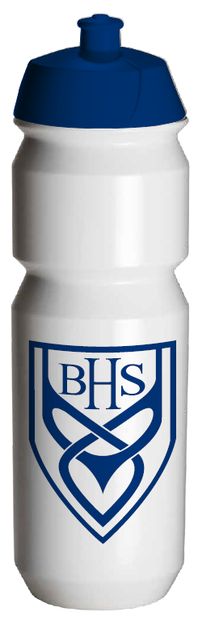
All funds raised by Hillary House selling the BHS water bottles will go to Hillary’s chosen local charity (currently Wish Upon a Dream) and to support our Action Aid child, Magret, in Zambia.
Features of BHS water bottle:
- Sports shape with push/pull cap
- Size: 750ml
- £5 per bottle
- Navy blue cap
- Room on base to write name
- Biodegradable (decomposes within 1-5 years once placed in landfill) but sunlight and heat do not affect the process.
If you have any questions regarding the water bottles, please email lucy.clarke@sch.im
--------------------------------------------------------------------------------------------
BHS water bottle order – cut off slip, place in envelope and hand into foyer
Pupil name and tutor group: ___________________________________________
Payment type (please circle): cash / cheque
Amount enclosed: £ ________
Signature: ____________________________
Bottles will be delivered to pupils in their tutor rooms - immediately for pupils currently at the school or as soon as they arrive into year 7.

