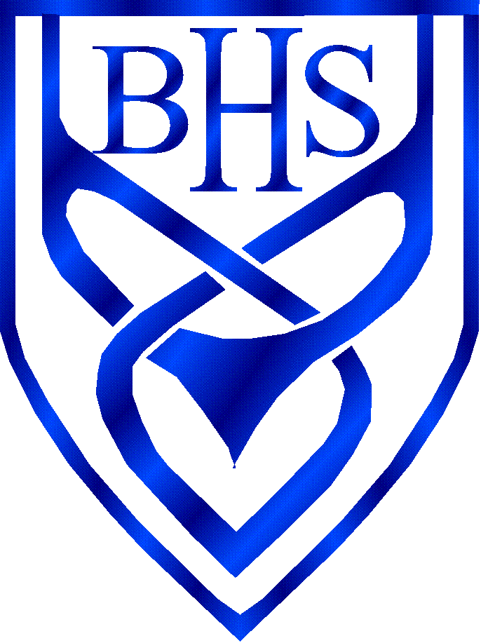
Wednesday 6th January

Closure of Schools due to Coronavirus

We would like to thank you all for your patience at this difficult time. As I am sure you heard yesterday, the Chief Minister ordered the closure of most schools for most students on the Isle of Man from the end of school today. Parents can choose to keep children off school without any concern of repercussion.

We know that parents/carers will seek to keep their children safe by keeping them at home, especially as we now know children can catch and transmit the virus, and will therefore follow the Government’s advice. We very much appreciate your support in this and know that, if we all work together, we have every chance of reducing the spread of Covid-19.

Although the Government has asked parents to keep their children at home wherever possible, schools will be open from Thursday 7th January 2021 for children of ‘key workers’ (as listed on the school and Government websites) or designated as ‘vulnerable’. That said, if key worker parents can make arrangements for their children to stay home, please do so. The fewer children making the journey to school and attending educational settings, the lower the risk of the virus spreading and infecting vulnerable individuals in wider society.

We would be grateful if you could let us know by email today bhsenquiries@sch.im if your child falls within the above categories and indicate if your child will be attending our hub from tomorrow.

Information for Parents Whose Children will attend a Hub
- Tomorrow, we ask that students attending school should arrive in Main Reception.

- They will be directed to a hub, where 2-metre social distancing will be in place. Students may wear a face covering if they wish to do so. They should wear their own clothes.

- If possible, students should also bring headphones, as they will be accessing on-line learning that may include audio recordings.

- The same times of the school day apply as usual, although each hub will have its own timetable and break and lunchtimes will need to be staggered.

Parents/carers should do everything in their power to ensure their children are not mixing socially in a way that could spread the virus. They should observe the same social distancing principles as adults.

Cont/….
If you are in receipt of Free School Meals
Families in receipt of free school meals will receive vouchers.

School Transport
Buses will run as usual until Friday. Next week, there is likely to be a revised bus schedule in place.

Online Learning
Appended to this letter is our guidance on Home Learning during School Closure. You can also find this information on the school website.

Exams
There are a number of BTEC exams scheduled to take place over the coming days and if your child is due to take these exams, parents are asked to wait for further information. We will contact you directly via In-Touch. If you think your child will need transport to school, please let us know by contacting bhsenquiries@sch.im and using the subject heading ‘Exams’, so we can deal with your query as a priority.

Thank you for your continued support and understanding. We will still be here for you during these difficult and unprecedented times. We know you will work with us in partnership and hope you will help us in implementing the arrangements above.

Best regards,

Adrienne Burnett

