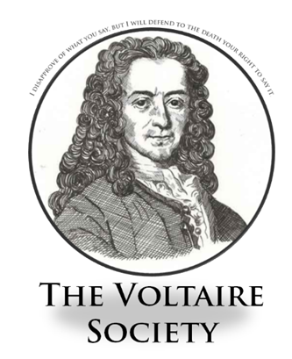
Voltaire Society - The Thin Blue Line ( 11 November )
This week’s meeting hosted Jon Nolan, member of the school’s Pastoral Support Team and erstwhile Sargent in the Cheshire Police. His illuminating talk covered a wide range of topics relating to the challenges of modern day policing in the UK, including the rise of narco-gangs and hardline political activism. Regaling the audience with tales drawn from a 29-year career, Mr Nolan illustrated how the role has evolved, from the way technology has changed the picture of crime, how the physical threat to officers has increased and how police uniform and equipment has had to adapt. Ultimately, however, he expressed the view that the job today involves the same core responsibilities as it did when he started on the force at the tender age of 18.
Having moved over last year, Mr Nolan reassured the assembled audience that the island is a much safer context but he reiterated his belief that society has the ultimate responsibility for determining its own laws and the way in which it should maintain order.
This was a very well received session and absolutely invites a follow-up in the New Year. It was particularly good to welcome so many blue jackets, from Years 7, 8 and 10. We hope to see more at the next meeting.

